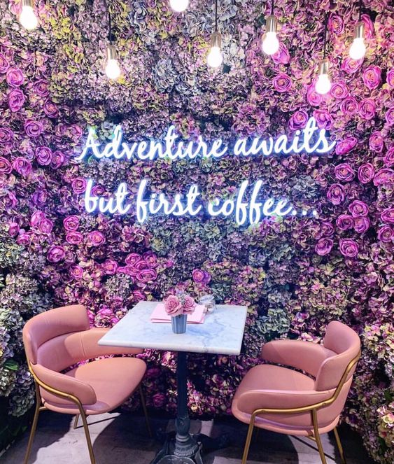

|  |
| --- |
| Sweet Lux |
|  |
| November 22  Sweet Lux  Authored by: Antoinette Alexander |

1. Company Description –

Sweet Lux is a café with a lounge area for completing work, reading, and an overall place to just relax that I am interested in creating. It combines several things that I thoroughly enjoy. Although this would be my first time managing all aspects of the business. My goal is to create a comfortable environment for people to spend their time during the day at the café catching up with friends or even completing work. The café will host many events in order to engage with the community and it will also offer a wide selection of desserts, coffee, and tea, and the menu will keep growing with suggestions.

The following are a few of the products to be offered by Sweet Lux:

* Local coffee (dark roast, light roast, medium roast, breakfast blend)
* Lattes
* Seasonal/holiday lattes
* Espressos
* Cappuccinos
* Bakery items baked fresh from local bakeries and delivered daily
* Paninis

The cafe location will be in either New York City, Dallas, or New Jersey cities where business professionals and college students live and work where they may need a break. These cities have the highest salaries and the highest amount of foot traffic with professionals of all ages.

Management Team

I would be the sole manager for the time being until I am able to hire someone that can help with that. I would have to host interviews in order to find the right people to work at the cafe. My goal is to hire natives so that they can genuinely connect with customers.

Aside from two other managers while I’m overseeing the upper management duties, Sweet Lux, will employ 4-5 baristas, and 1 social media and website manager.

Success Factors

Sweet Lux is primed for success at whatever location I will choose.

* Local businesses in the neighborhood I chose would be eager to work with Sweet Lux

due to our commitment to serving quality coffee/baked goods and sandwiches all while creating a safe and lovely environment to relax and unwind with exceptional customer service. and delivering exceptional customer service.

1. Problem -   
   The main problem that the company can deal with is making sure that we have a good CRM system, payment processor, order online and pick up, and keeping the menu online up to date. Doing this allows the customer to feel engaged with the restaurant and get a feel of what we have to offer before they come into the establishment. We would also have to develop café and bar inventory management, a point-of-sale system, event management software, and café/lounge marketing solutions. This allows us as business owners to keep everything maintained as well as allow the employees to conduct day-to-day operations inside of the business.
2. Requirements -   
   The requirements for the CRM include receiving, storing, and keeping track of information about customers including their contact information, birthdays, how many times they frequent the store, and their most frequented order. The point-of-sale system for the employees will allow them to put the orders that the customers make, the system will also collect common information about the customer, such as name, address, phone, and email. Information about the current work order would include entering service type, parts used, technician id, time in, time out, and any recommendations, and the application needs to display the date of the last time the current service was performed on the auto if known.
3. Description of User Interface (GUI) –

After arriving at the main screen, it will show the many different options available on site. The email form will have text boxes for entering new customer information, labels to designate where to input information, and buttons to submit the form. The online order form will be for ordering online for pick up. There you can select your order with the radio buttons added and anything that you want to add with radio buttons as well. There will also be a calculate button for you to know your total and a place order button for you to submit your order and receive your order confirmation number. The gift card form will be used to buy digital gift cards for yourself or someone else to gain reward points. It will have checkboxes to select the services and labels to display pricing and calculate button to confirm the total price you will be paying along with telling you how many rewards points you will receive. There is also an even page that keeps you up to date with the fun things happening at the café. On this form, there are rich text boxes that allow you to write a lot of information in them along with labels and buttons to sign up. The membership page has labels and a textbox for your names. There are also two buttons to create an account and to clear any mistakes after entering information. There is also a checkbox that allows you to receive emails from Sweet Lux about events.

(main page)

(Order form)

(Event form)

(Membership page)

* 1. Functionalities -   
     Using the information provided in the membership it will help management and servers to enter and receive customer information with ease. By using this application, the customer information will be stored in the database so they will be able to receive updates and rewards, and birthday surprises as well for being a valued customer. I will also be able to figure out the operations management aspect of the business and will also be able to figure out what is needed to be ordered, and what our most popular selling item is based on the orders added to the database. It will also help me with forecasting, so I know what I need to order and how much and when based on the data in the database. add new autos to the database when a customer brings them in for an initial service.
  2. Description of Database and Data Types -   
     The database is a simple table that is used for filling in the order id and inputting what was ordered that day. Whenever there is an order placed by a customer, the data will be saved in the database relations for the OrderID. There are relations in the database referring to ITEM, QUANTITY, and BILLS that will store information about the inventory. The data types of the database will include integers, strings, and doubles. Numbers such as order quantity and price will be stored as integers, and the customer names, email addresses, phone numbers and will be stored as strings.

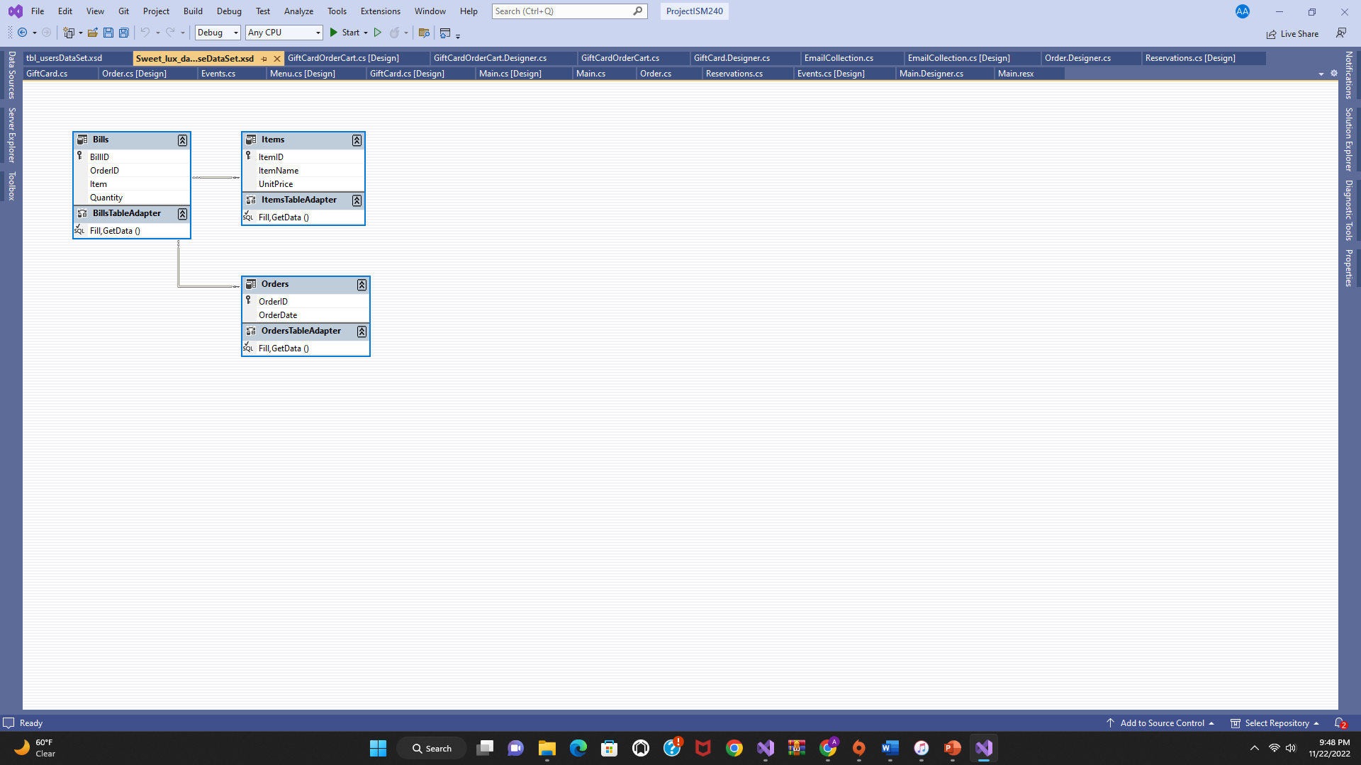(order database)